**Problem statement and business case**

1. The bank marketing team would like to leverage Machine Learning to launch a targeted marketing ad campaign that is tailored to specific group of customers.
2. In order for this campaign to be successful, the bank has to divide its customers into at least 3 distinctive groups.
3. This process is known as “marketing segmentation” and it’s crucial for maximizing marketing campaign conversion rate.

**Data**

[**https://www.kaggle.com/arjunbhasin2013/ccdata**](https://www.kaggle.com/arjunbhasin2013/ccdata)

This case requires to develop a customer segmentation to define marketing strategy. The  
sample Dataset summarizes the usage behavior of about 9000 active credit card holders during the last 6 months. The file is at a customer level with 18 behavioral variables.

Following is the Data Dictionary for Credit Card dataset :-

**CUST**ID : Identification of Credit Card holder (Categorical)  
**BALANCE** : Balance amount left in their account to make purchases (  
**BALANCEFREQUENCY** : How frequently the Balance is updated, score between 0 and 1 (1 = frequently updated, 0 = not frequently updated)  
**PURCHASES** : Amount of purchases made from account  
**ONEOFF**PURCHASES : Maximum purchase amount done in one-go  
**INSTALLMENTSPURCHASES** : Amount of purchase done in installment  
**CASH**ADVANCE : Cash in advance given by the user  
**PURCHASESFREQUENCY** : How frequently the Purchases are being made, score between 0 and 1 (1 = frequently purchased, 0 = not frequently purchased)  
**ONEOFFPURCHASESFREQUENCY** : How frequently Purchases are happening in one-go (1 = frequently purchased, 0 = not frequently purchased)  
**PURCHASESINSTALLMENTSFREQUENCY** : How frequently purchases in installments are being done (1 = frequently done, 0 = not frequently done)  
**CASHADVANCEFREQUENCY** : How frequently the cash in advance being paid  
**CASHADVANCETRX** : Number of Transactions made with "Cash in Advanced"  
**PURCHASES**TRX : Numbe of purchase transactions made  
**CREDITLIMIT** : Limit of Credit Card for user  
**PAYMENTS** : Amount of Payment done by user  
**MINIMUM_PAYMENTS** : Minimum amount of payments made by user  
**PRCFULLPAYMENT** : Percent of full payment paid by user  
**TENURE** : Tenure of credit card service for user

**Credit card customer segmentation**

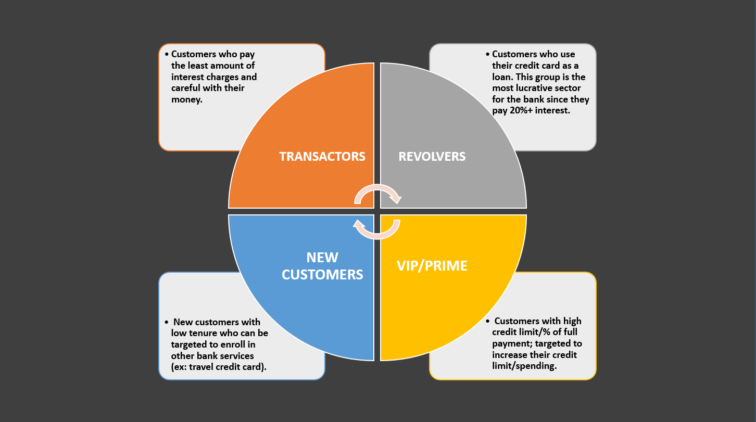

**ELBOW METHOD**

* The elbow method is a heuristic method of interpretation and validation of consistency within cluster analysis designed to help find the appropriate number of clusters in a dataset.
* If the line chart looks like an arm, then the "elbow" on the arm is the value of k that is the best.
* Source:
  + <https://en.wikipedia.org/wiki/Elbow_method_(clustering)>
  + <https://www.geeksforgeeks.org/elbow-method-for-optimal-value-of-k-in-kmeans/>